Global Economic and Demographic Trends Analysis

Objectives :

This project analysis GDP growth, population dynamics, literacy rates, and employment trends to understand global development. It examines birth and death rates to assess population sustainability and economic stability. Key economic indicators like GDP per capita and living standards are compared across regions. The study highlights regional disparities and growth opportunities through data-driven insights. Interactive Power BI dashboards are used to visualize trends for better decision-making.

Dataset Overview :

* Countries World -MySQL Database
* Meta Data Country-CSV
* Population per Country-CSV
* GDP by Country 1960-1980-Excel
* GDP by Country 1980-2000-Excel
* GDP by Country 2000-2016-Excel

Tools Used :

* Excel
* MySQL
* Statistics
* Power BI

Steps Involved :

1. Data Cleaning

* Handled Missing Values
* Removed Duplicates
* Replaced Null values
* Merged tables

1. Descriptive Statistical Analysis :

* Descriptive statistical analysis in this project helps summarize and interpret key economic and demographic data through measures like,
* Mean
* Median
* Mode
* Standard Deviation
* Used these statistical calculations across different countries by population, GDP values and Infant Mortality.

1. DAX Calculations :

DAX measures in this project are used to perform dynamic calculations on key metrics like GDP growth, literacy rates, and population trends for deeper insights.

* Calculated the population growth rate over time
* Calculated the GDP growth rate.
* Created calculated columns for GDP per capita.
* Aggregated population or GDP data by region.
* Derived insights such as the correlation between literacy rates and GDP.

1. Data Visualization :

Power BI was used to create interactive visualizations for analyzing GDP trends, population dynamics, and literacy rates across regions. Its powerful dashboards and data modeling enabled clear insights and effective storytelling for decision-making.

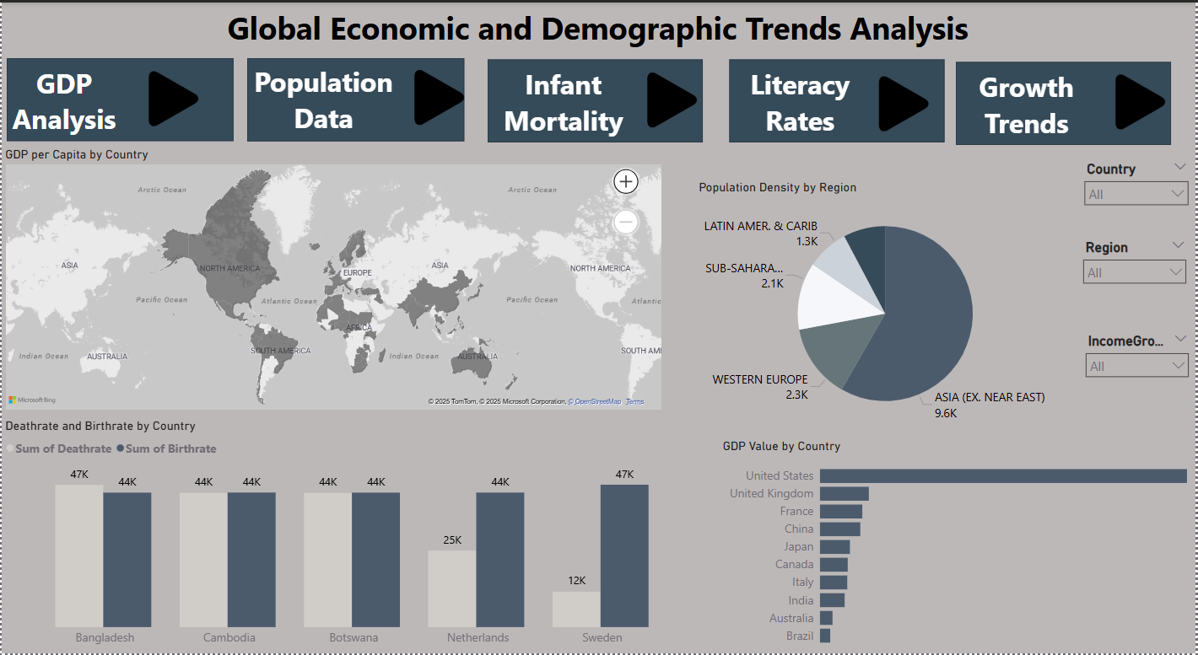

The dashboard above visualizes key insights on global GDP, population trends, literacy rates, and economic indicators. It provides an interactive view of how different regions compare in terms of economic growth, demographic changes, and development factors*.*

1. Insights :

* Luxembourg has the highest GDP per capita, reaching $55,100, reflecting its strong economic performance.
* East Timor, Sierra Leone, and Somalia have the lowest GDP per capita, recorded at $500, indicating economic challenges in these countries.
* East Timor have the lowest infant mortality rates.
* American Samoa is the highest infant mortality rates.
* China leads with 1.3 billion, followed by India at 1.0 billion, then the United States, Indonesia, and Brazil, reflecting rapid growth particularly in Asia.

1. Recommendations :

* Strengthen Healthcare in High Infant Mortality Regions.
* Strengthen Infrastructure & Business Environment for GDP.
* High-income countries (Luxembourg) can partner with lower-income countries (East Timor) to transfer technology and expertise.
* Focus on education and vocational training to boost economic growth.
* Encourage technology adoption and support local industries and Investment in Education to improve GDP per capita.
* Build more schools in rural and underserved areas to improve Literacy Rates.

1. Conclusion :

This analysis provides valuable insights into global economic and demographic trends, highlighting key factors like GDP growth, population dynamics, and literacy rates. The findings reveal regional disparities, economic strengths, and areas needing improvement. By leveraging Power BI visualizations, this project enables data-driven decision-making for policymakers, businesses, and researchers. Understanding these trends is crucial for sustainable economic growth and social development.